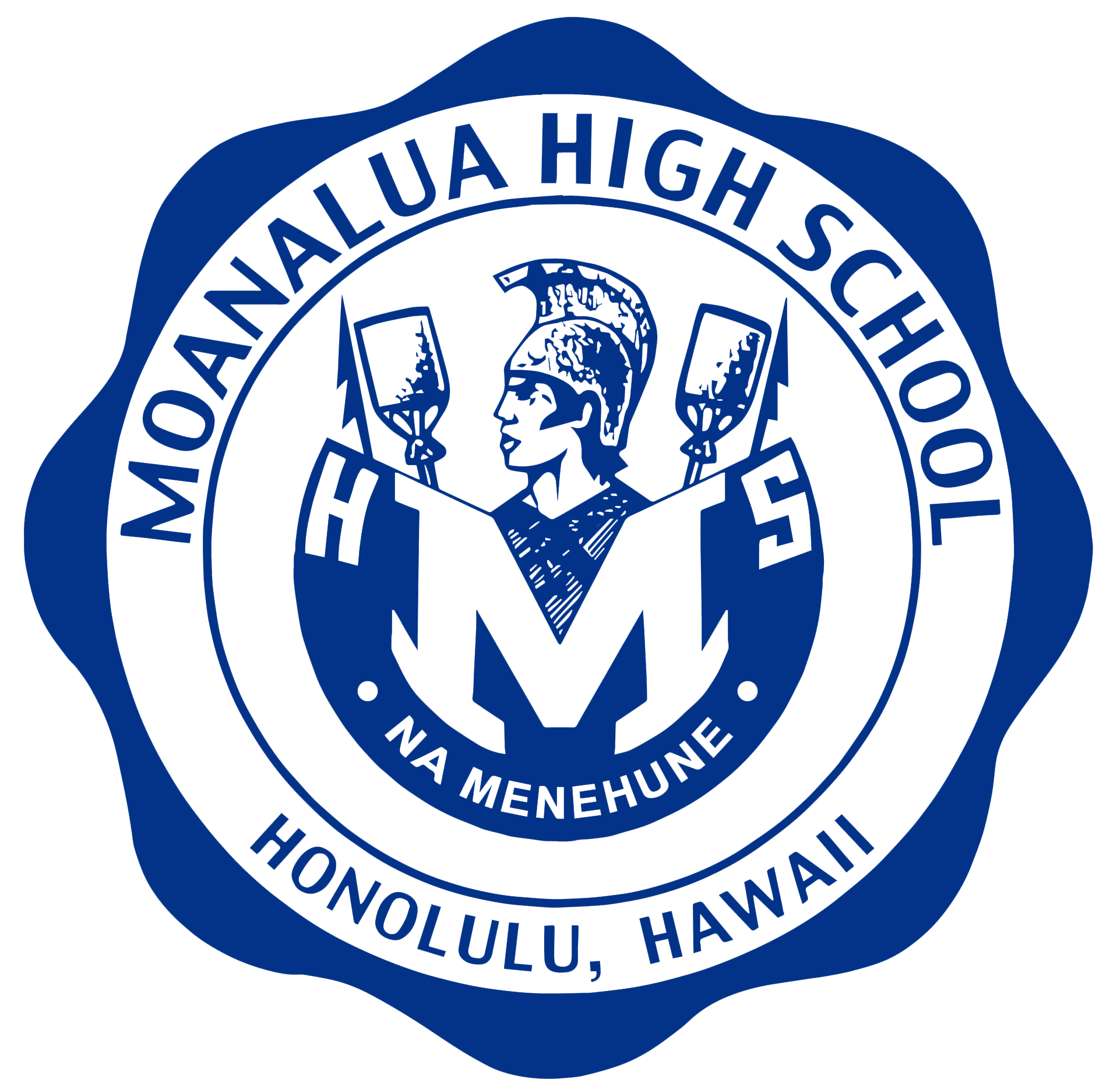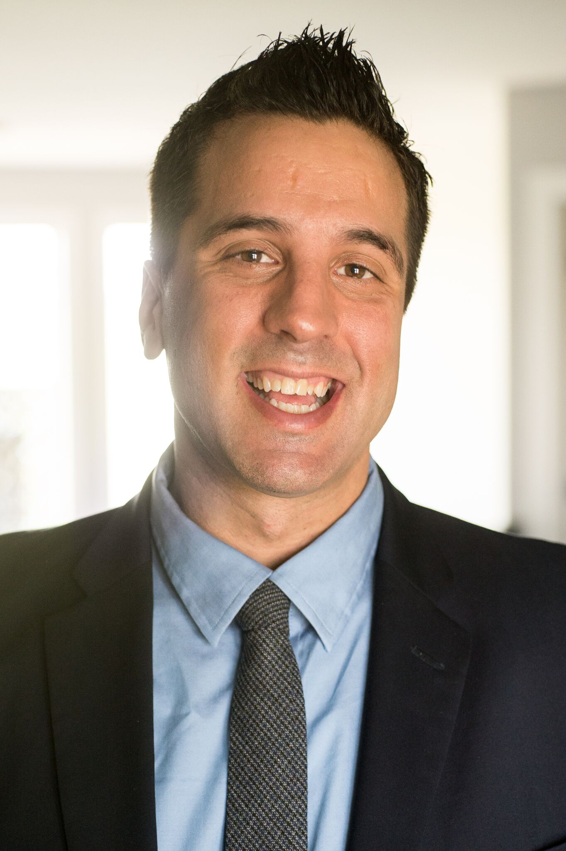

Moanalua High School

In conjunction with Hawaii ASCD

**18th Annual Professional Development Conference**

**Conversations for Learning:**

**Creating a Culture of Innovation**

Friday, April 5, 2019  8:15 am – 3:30 pm

Moanalua High School Cafeteria

Sessions are designed for K-12 and beyond!

**Featured Speaker: George Couros**

George Couros is a leading educator in the area of innovative leadership, teaching, and learning. He has worked with all levels of school, from K-12 as a teacher, technology facilitator, and school and district administrator, and is the author of the book,

*The Innovator’s Mindset; Empower Learning, Unleash Talent, and Lead a Culture of Creativity*. He is a sought after speaker on the topic of innovative student learning and engagement and has worked with schools and organizations around the globe. George is also the creator of Connected Principals.com, an initiative that brings educators and leaders together from around the world to create powerful learning opportunities for students.

**Date: April 5, 2019**

**Registration: 7:30 a.m.**

**Time: 8:15 a.m. – 3:30 p.m.**

**$100 per person**

Register today at <http://bit.ly/mohspd>. (Closes March 22nd, 2019)